Task 2:

[Hello World Docker Image](https://hub.docker.com/_/hello-world) Run Hello World Docker Image Locally.

Pull from docker hub

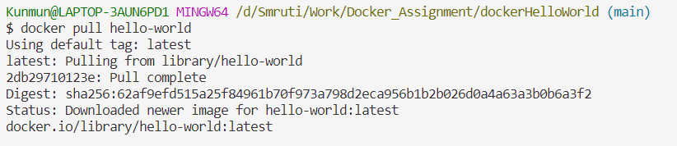

Check docker images

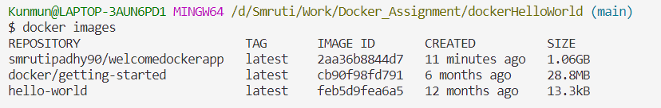

Run image

